Class: Final Year B.Tech(Computer Science and Engineering)

Year: 2025-26 Semester: 1

Course: High Performance Computing Lab

**Practical No. 5**

**Exam Seat No: 23520012**

Title of practical: Implementation of OpenMP programs.

Implement following Programs using OpenMP with C:

Implementation of Matrix-Matrix Multiplication.

The sequential version takes time proportional to O(n^3). Using **OpenMP**, we can parallelize the multiplication since each element of C can be computed independently.

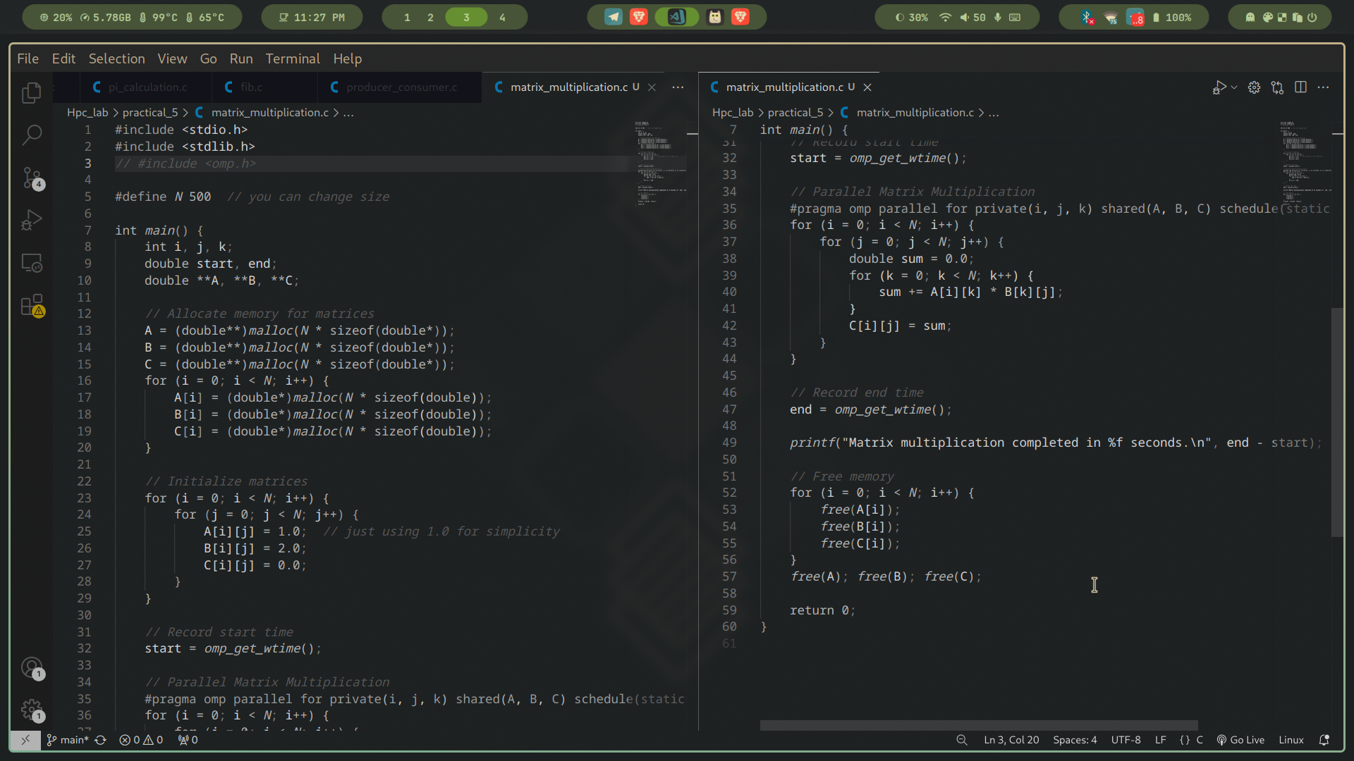

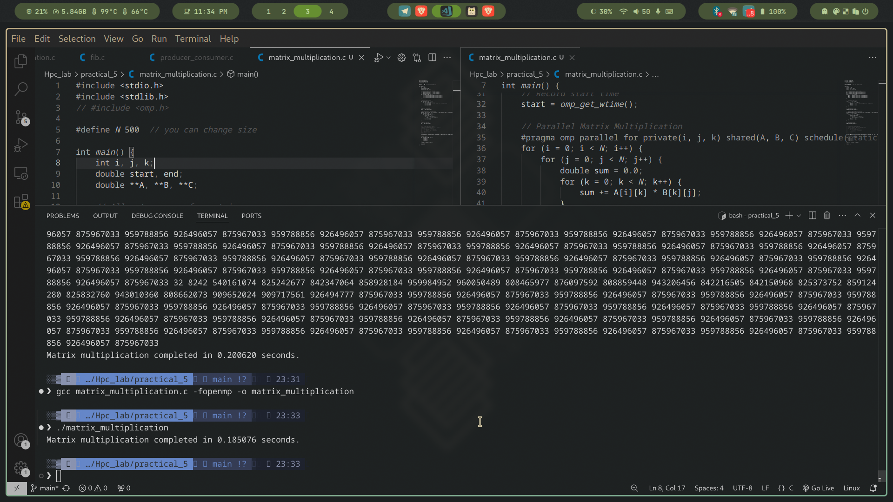

**Initialization**

* Three matrices A, B, and C are created.
* Initialized with simple values (1.0, 2.0) so results are predictable.

**Parallelization (#pragma omp parallel for)**

* The **outer loop** (i) is parallelized.
* Each thread computes one row of C.
* private(i, j, k) ensures loop variables don’t clash.
* shared(A, B, C) means all threads use the same input matrices.

**Load Balancing**

* schedule(static) divides rows equally among threads.
* Alternative: schedule(dynamic) for irregular workloads.

**Synchronization**

* Each thread writes to a unique (i, j) element of C.
* So **no race condition** → no need for critical sections.

**Time Measurement**

* omp_get_wtime() is used to measure performance.
* Helps calculate **speedup** compared to sequential.

**parallel for** -> to distribute loop iterations.

**private and shared** clauses -> avoid race conditions.

**schedule** clause -> controls work distribution.

Implementation of Matrix-scalar Multiplication.

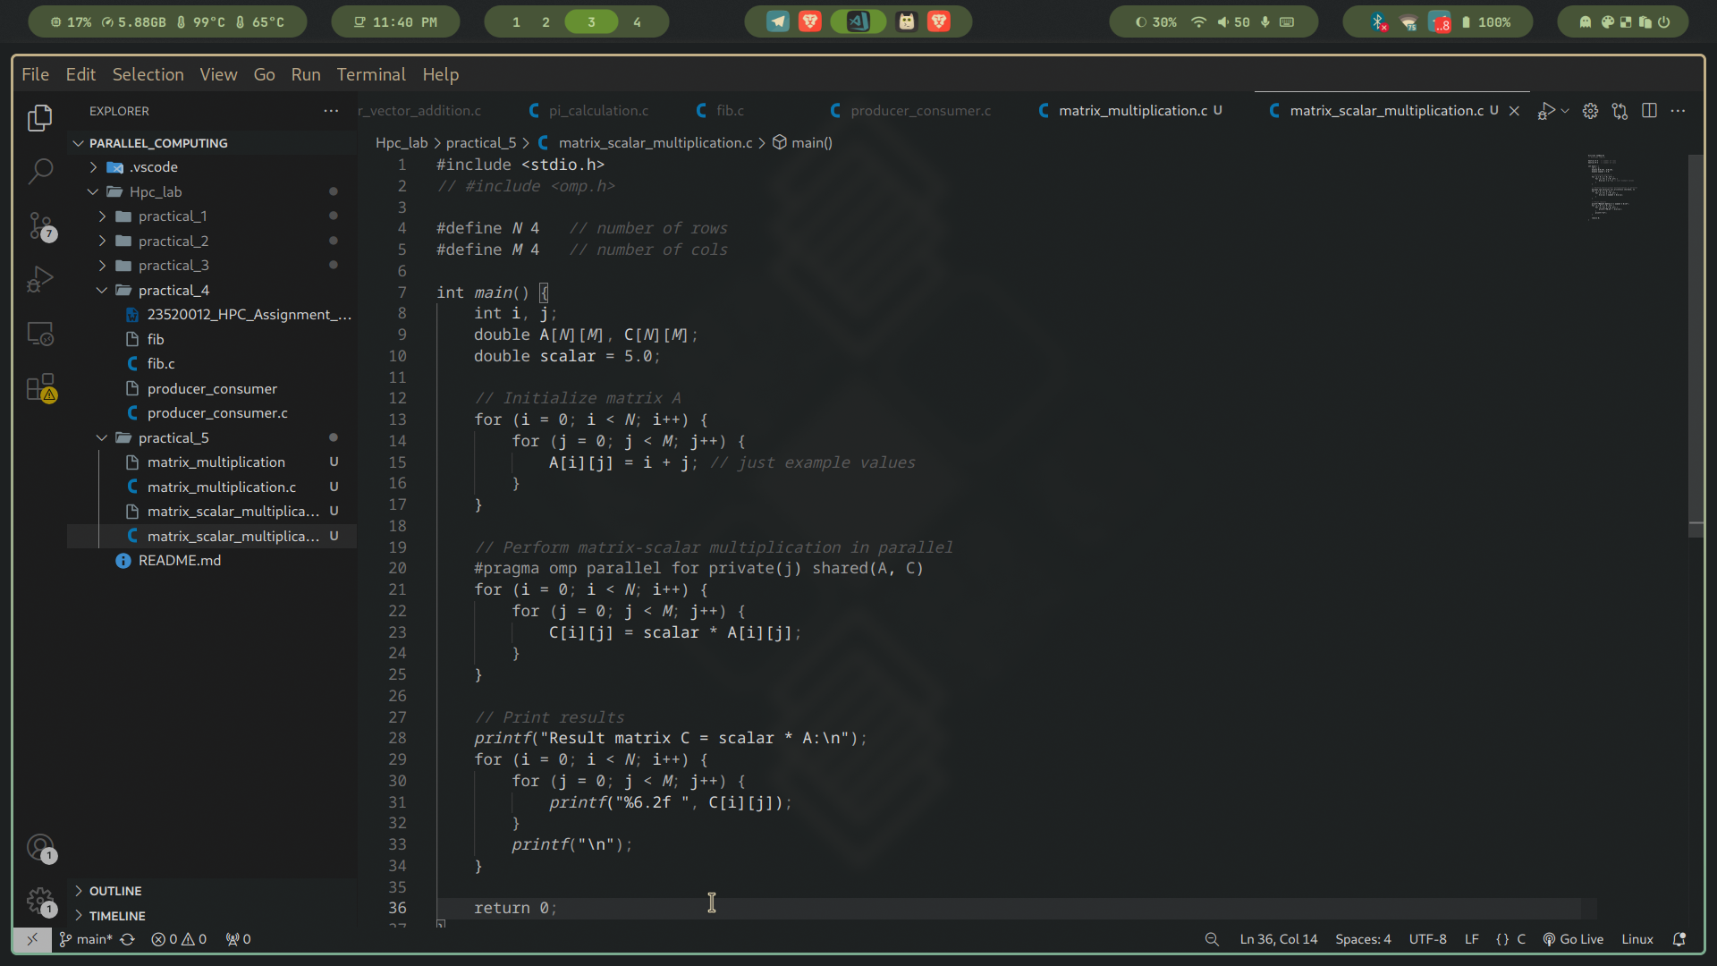

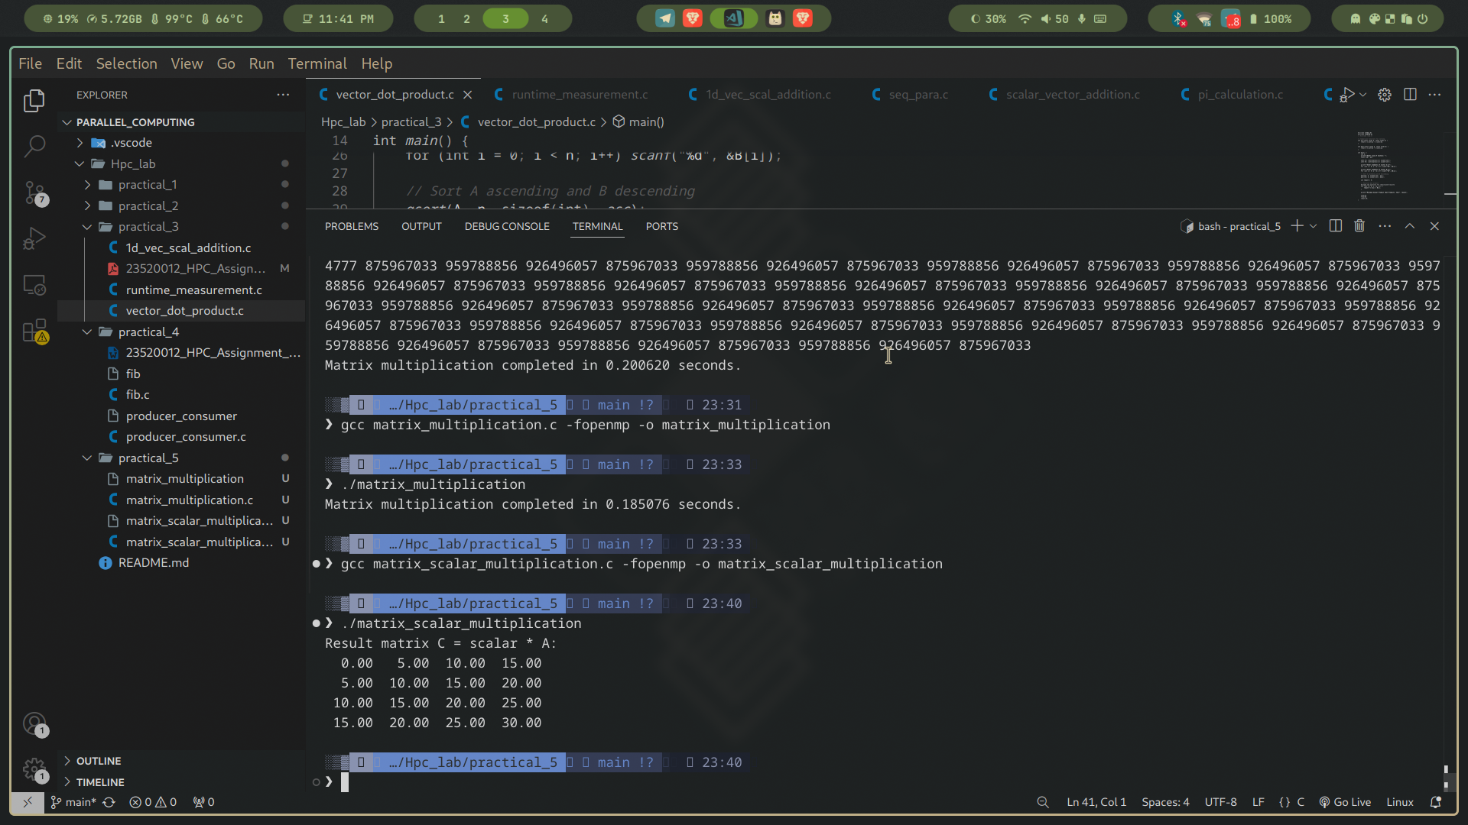

**Workload Distribution**: Each element can be processed independently, so iterations over rows and columns can be parallelized.

**Synchronization Requirements**: No need for locks or synchronization because no two threads update the same memory location at the same time.

**OpenMP Constructs Used**:

* #pragma omp parallel for → to parallelize the loop over rows and columns.
* private clause for loop variables to avoid conflicts.
* shared clause for input/output matrices and scalar.
* **Parallelism**: Since all elements are independent, performance scales almost linearly with available cores.
* **No Synchronization Overhead**: No locks/barriers needed (except implicit barrier at the end of parallel for).
* **Clauses Used**:  
  + collapse(2) → merges two nested loops (row and column) into one for better parallelization.
  + shared(A, B, scalar) → input and output arrays shared among threads.
  + private(i, j) → each thread gets its own loop indices.

Implementation of Matrix-Vector Multiplication.

* Each row of the matrix can be computed **independently**, because y[i] only depends on row i of A and the vector x.
* This makes the operation **embarrassingly parallel**, so OpenMP is perfect here.

We have used:

* #pragma omp parallel for → distributes rows among available threads.
* Private variables for temporary sums (sum) inside each iteration.
* Shared variables for A, x, and y.

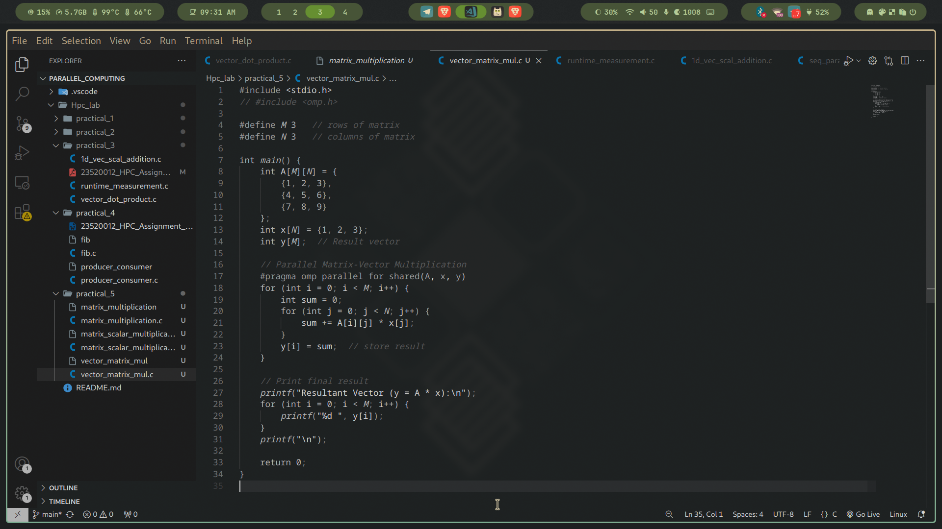

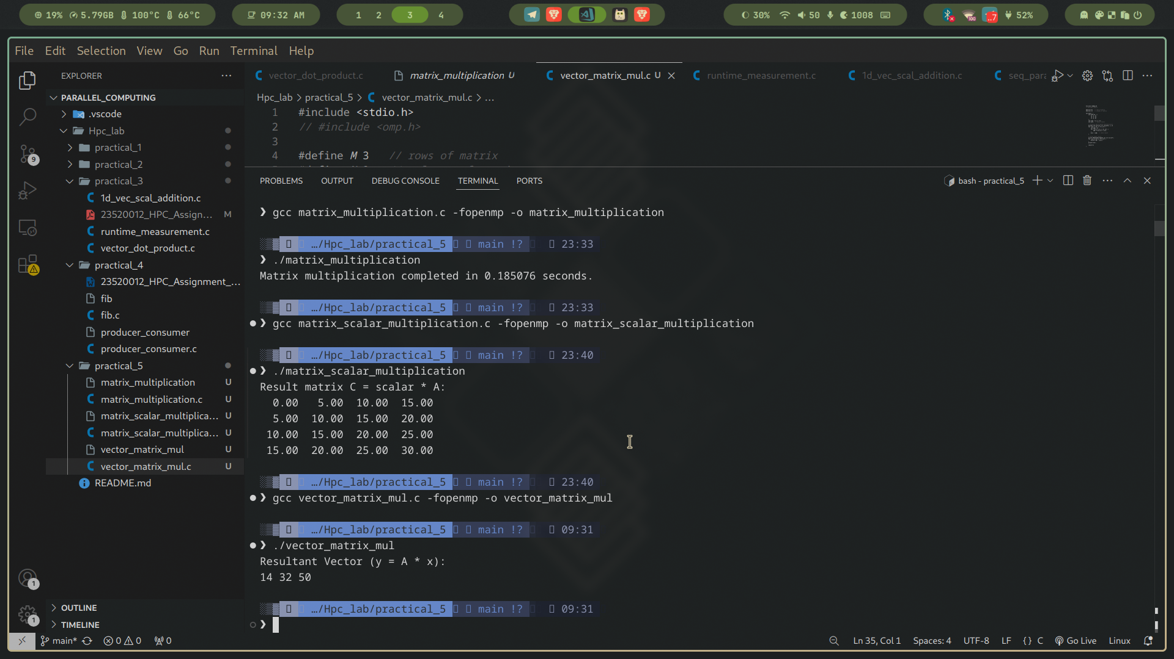

**Matrix and Vector Declaration**

* A 3x3 matrix A and vector x are defined.
* Result vector y will hold the output.

**Parallel Region**

* #pragma omp parallel for → distributes the outer loop (rows of the matrix) among threads.
* Each thread calculates the sum of products for its assigned row.

**Synchronization**

* No explicit synchronization is needed because each thread writes to a unique index y[i].
* OpenMP ensures safe execution as no two threads update the same location.

**Result Printing**

* The final vector y is printed after the parallel computation is complete.

Implementation of Prefix sum.

Unlike matrix multiplication, prefix sum has **dependencies**:

* To compute P[i], you need P[i-1].
* This introduces a **synchronization requirement**.

We can solve this using **parallel algorithms like Hillis–Steele scan** or by careful **synchronization with barriers** in OpenMP.

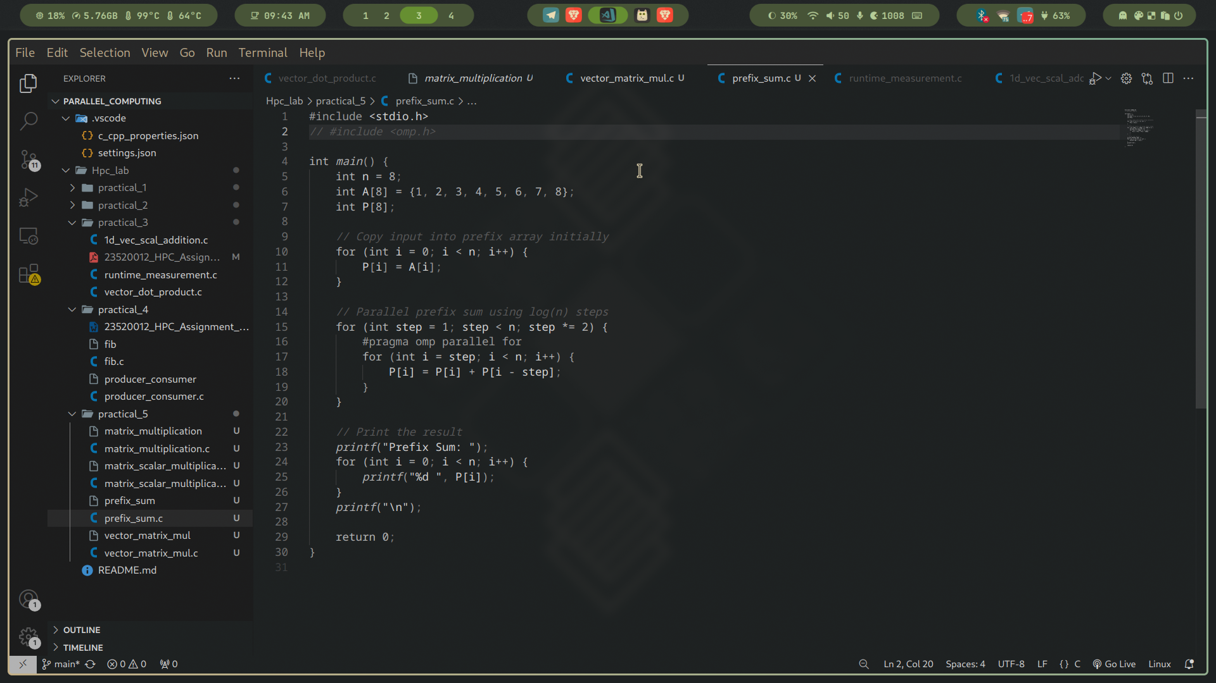

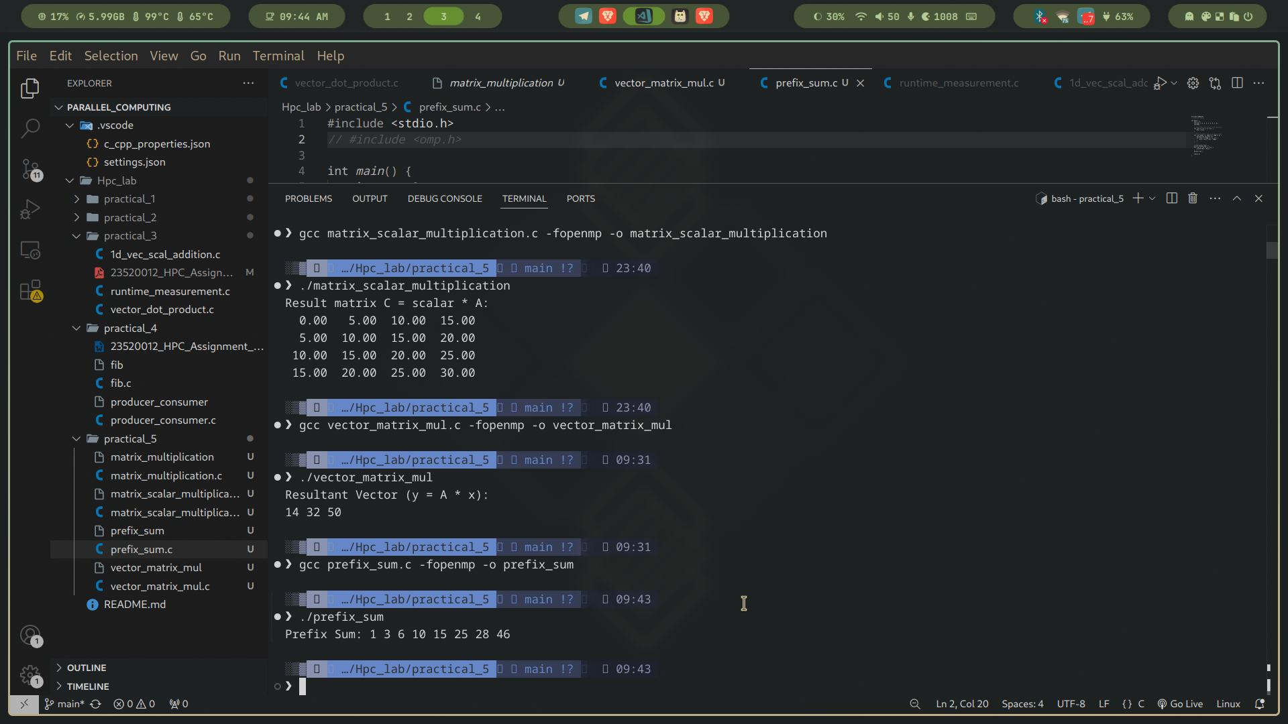

1. **Initialization**
   * We start with an array A and copy its contents into P.
2. **Iterative Steps (log n levels)**
   * At each step, every element at index i adds the value from i-step.
   * Example progression (for A = [1,2,3,4]):  
     + Step = 1: [1, (2+1), (3+2), (4+3)] → [1,3,5,7]
     + Step = 2: [1,3, (5+1), (7+3)] → [1,3,6,10]
3. **OpenMP Parallelization**
   * #pragma omp parallel for parallelizes the inner loop.
   * Each step is independent across elements (but **depends on previous step** → why we keep outer loop sequential).
4. **Synchronization**
   * After each step, threads are synchronized automatically since each iteration of the outer loop waits for the parallel for to finish.
5. **Output**
   * The prefix sum array is printed at the end.